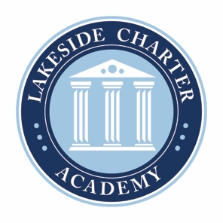
Lakeside Charter Academy, in partnership with parents, will cultivate engaged learners through scholarship, leadership, and citizenship
Agenda: Lakeside Charter Academy
April 28, 2022
Regular Meeting
Board of Directors Meeting

Location: Conference Call
ZOOM _______________________

April 28, 2022, | 6PM EST

- Call to Order
- Reading of Conflict of Interest Statement
- Approval of March 24 Minutes*
- Reports – Principal report, Marketing, enrollment update, Knight’s Game, Bus Driver
- Business Manager
  - March Budget Update
  - Board Elections discussions
  - Board Committees discussions
  - Approval of Jay Sharp for Audit*

- Parent Comment – Andressa Jacovozzi
- Adjourn

* Requires Board Action

