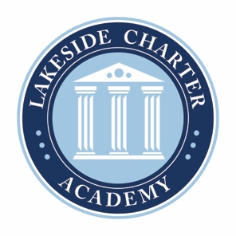
Lakeside Charter Academy, in partnership with parents, will cultivate engaged learners through scholarship, leadership, and citizenship
Agenda: Lakeside Charter Academy
Special Meeting
Board of Directors Meeting

Location: Conference Call
202.926.1041; 555810

December 16, 2021 | 12PM EST

- Call to Order
- Reading of Conflict of Interest Statement
- Approval of October 2021 Minutes*
- Reports – Principal report, Marketing, enrollment update,
  - Mask Policy*
- Adjourn

* Requires Board Action

