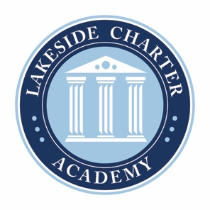
Lakeside Charter Academy, in partnership with parents, will cultivate engaged learners through scholarship, leadership, and citizenship
Agenda: Lakeside Charter Academy
Regular Meeting
Board of Directors Meeting

Location: Conference Call
712.451.0432; 555810

May 27, 2021 | 7PM EST

- Call to Order
- Reading of Conflict of Interest Statement
- Approval of April 22, 2021, Minutes*
- Reports – Principal report, FEA report, NC CHECK-INS, enrollment update, handbooks and policy changes, enrollment/marketing, activities/Friday Forums, parent surveys, PAT, online education, iReady, academic update, contingency plan, etc.
- Federal Monitoring
- Charter Renewal Update – Jim and Susanne
- Finance – Business manager
  - Review Statements
  - 2021-22 &2022-23 Budget Review discussion and approval*
  - Transportation Policy*
  - Technology Policy*
  - Bus Driver Policy*
  - Fundraising Status update
  - School Space – Daycare, Church
  - Staffing approval and updates, if applicable*
- Adjourn

* Requires Board Action

