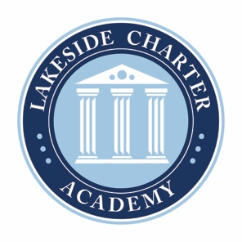
Lakeside Charter Academy, in partnership with parents, will cultivate engaged learners through scholarship, leadership, and citizenship
Agenda: Lakeside Charter Academy
Special Meeting
Board of Directors Meeting

Location: Conference Call
202.926.1041; 555810

November 18, 2021 | 11AM EST

- Call to Order
- Reading of Conflict of Interest Statement
- Approval of October 2021 Minutes*
- Reports – Principal report, Marketing, NC CHECK-INS, enrollment update,
  - Mask Policy*
  - Hires – Mckernan for Silva, Tramaine – Transportation*
- Adjourn

* Requires Board Action

